STATIONS
OF THE RESURRECTION

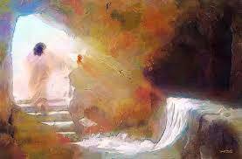

Stations of the Resurrection are similar to the traditional Stations of the Cross, taking a few verses from Scripture, a short meditation and a prayer.

The first Easter Day
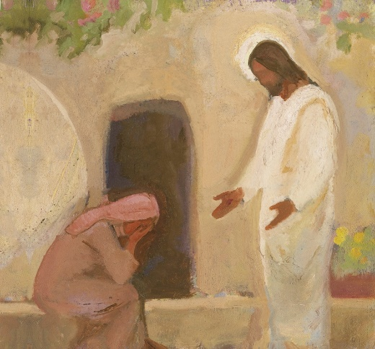
Alleluia! Christ is risen. He is risen indeed. Alleluia!

“Mary turned round and saw Jesus standing, but she did not know it was Jesus. Jesus said to her, ‘Woman, why are you weeping? Whom do you seek?’ Supposing him to be the gardener, she said to him, ‘Sir if you have carried him away tell me where you have laid him, and I will take him away.’ Jesus said to her, ‘Mary’. She
turned and said to him in Hebrew, ‘Rabboni!’ (which means Teacher).” Jn20 14-16

Often our difficulty lies in recognising the obvious when we are not expecting it - seeing Jesus close to us, in the people around us. We mistake their identity. Yet when we are named and name others in turn, such mistakes fall away and we can discover who we really are, and encourage others to be themselves, without a mask.

Lord, help me to find you in all different kinds of people, to allow their reality to be present and to have the courage to be real myself.

The Emmaus Road experience

Alleluia! Christ is risen. He is risen indeed. Alleluia!
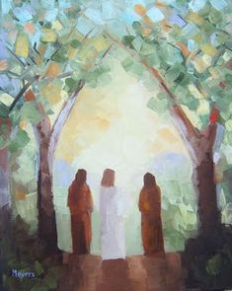
“That very day two of the disciples were going to a village named Emmaus, about seven miles from Jerusalem, and talking with each other about all these things which had happened. While they were talking and discussing together, Jesus himself drew near and went with them. But their eyes were kept from recognising him. ...When Jesus was at table with them, he took the bread and blessed, and broke it, and gave it to them. And their eyes were opened and they recognised him; and he vanished out of their sight. They said to each other, ‘Did not our hearts burn within us while he talked to us on the road, while he opened to us the scriptures.’” Lk 24, 13-16, 30-32

The central action of the Eucharist is a very simple one: taking, blessing, breaking and sharing bread; pouring, blessing and sharing wine. When we re-enact the Last Supper, Jesus is once again real among us, and we recognise him in the breaking of bread.

Lord, as we your disciples celebrate your Eucharist, come among us in the simplicity of bread and wine, and enflame our hearts as you did of those on the road to Emmaus.

Breakfast on the beach

Alleluia! Christ is risen. He is risen indeed. Alleluia!

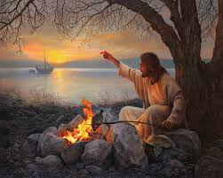
“When the disciples got out on land, they saw a charcoal fire there, with fish lying on it, and bread. Jesus said to them, ‘Bring some of the fish that you have just caught.’ So Simon Peter went aboard and hauled the net ashore, full of large fish, a hundred and fifty-three of them; although the net was not torn. Jesus said to them, ‘Come and have breakfast.’ Now none of the disciples dared ask him, ‘Who are you?’ They knew it was the Lord. Jesus came and took the bread and gave it to them, and so with the fish. This was now the third time that Jesus was revealed to the disciples after he was raised from the dead.” (Jn 21, 9-14)

Jesus invites us to share a meal with him, just as he invited the large crowds to share bread and fish by the Sea of Galilee, as he here invites the early disciples to have breakfast, as he invites all to participate in the great heavenly banquet of the Kingdom of God. By accepting that invitation we join with others to form a community, not simply for ourselves, but to be co-workers with him to make the Kingdom a reality.

Lord, help us to accept your invitation to share food and so risk becoming part of the community which makes you real here, in your life, in your death and in your resurrection.

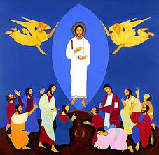
Jesus returns to his Father

Alleluia! Christ is risen. He is risen indeed. Alleluia!

“In the first book, O Theophilus, I have dealt with all that Jesus began to do and teach, until the day when he was taken up, after he had given commandment through the Holy Spirit to the apostles whom he had chosen. To them he presented himself alive after his passion by many proofs, appearing to them during forty days, and speaking of the kingdom of God. And while staying with them he charged them not to depart from Jerusalem, but wait for the promise of the Father, which he said, ‘you heard from me, for John baptizes with water, but before many days you shall be baptized with the Holy Spirit.’ ... as they were looking on, he was lifted up, and a cloud took him out of their sight.” Acts 1. 1-5 & 9

Our understanding of the Ascension may be blocked by our asking obvious (but too tempting) questions about where exactly Jesus went and how. This is not helped, admittedly, by stained-glass windows showing a pair of disappearing feet! Rather, we witness the return of the risen Jesus to his Father, taking with him not simply some godly, ghostly character, but in his full humanity - the glory of God and the glory of humanity coming back to the generous welcome of God the Father.

Lord, help us to accept our own humanity in all its glory and all it weakness as you accepted Jesus; and through him, bring us to your kingdom.
The coming of the Holy Spirit

Alleluia! Christ is risen. He is risen indeed. Alleluia!

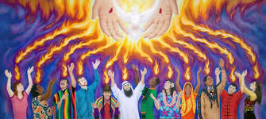

“When the day of Pentecost had come, they were all together in one place. And suddenly a sound came from heaven like the rush of a mighty wind, and it filled all the house where they were sitting. And there appeared to them tongues as of fire, distributed and resting on each of them. And they were all filled with the Holy Spirit and began to speak in tongues, as the Spirit gave them utterance.” Acts 2. 1-4

It is the Spirit which enlivens us, makes us real as human beings, gives us life in its fullness, and the courage to live, speak and enact the gospel. The first disciples were accused of drunkenness early in the morning - let us not be dead Christians but alive to challenge and support the society and church around us.

Lord, fill us with your Spirit, so that the poor hear the good news, those who are enslaved are set free, the blind may see, and all proclaim your year of Jubilee.

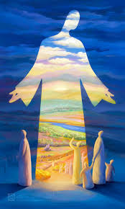
Come, my Way, my Truth, my Life:
Such a Way, as gives us breath:
Such a Truth, as ends all strife:
Such a Life, as killeth death.

Come, my Light, my Feast, my Strength:
Such a Light, as shows a feast:
Such a Feast, as mends in length:
Such a Strength, as makes his guest.

Come my Joy, my Love, my Heart:
Such a Joy, as none can move:
Such a Love, as none can part:
Such a Heart, as joys in Love.

George Herbert

